AIAC Assignment 2.3

Name: N.Nithin Varma
HT No : 2303A52011
Batch 31

Question
Task 1:
Word Frequency from Text File
Scenario: You are analyzing log files for keyword frequency. Task: Use Gemini to generate Python code that reads a text file and counts word frequency, then explains the code
Promt:

Create a Python program that creates a text file, writes sample text into it, then reads the file and displays its contents.
Add clear comments in the code.

code screenshot
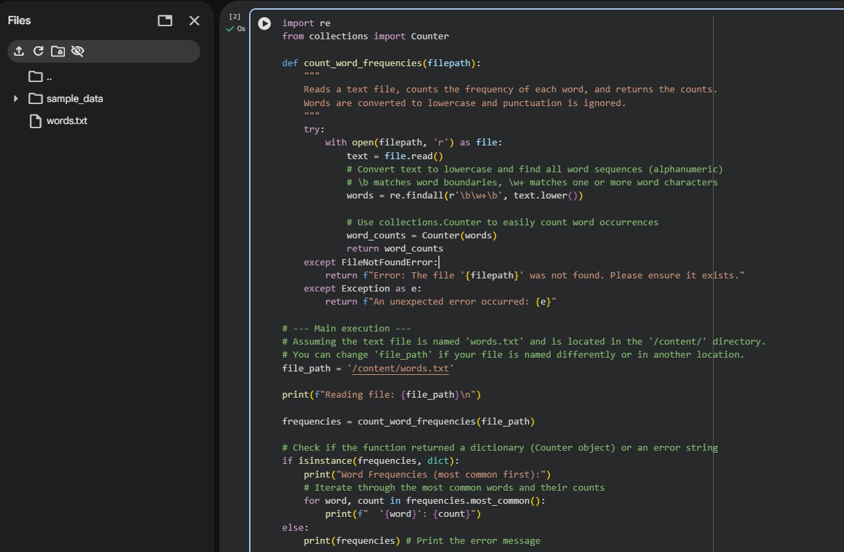
Output
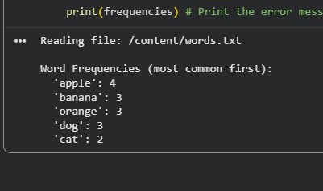

Explaination
This program starts by reading all the text inside a file and breaking it down into individual words. It keeps a running tally of every word it finds by storing them in a list. Every time the program comes across a word it has seen before, it simply adds one to that word's specific total. Once it finishes reading the entire file, it shows you the final count for every word it found. This makes it easy to see exactly which words were used the most throughout the text.Question
Task 2:
File Operations Using Cursor AI
Scenario: You are automating basic file operations.
Task: Use Cursor AI to generate a program that:
Creates a text file
Writes sample text
Reads and displays the content
prompt
generate a python program, which creates a text file, write sample txt eg.fruits in that, read and display that content.
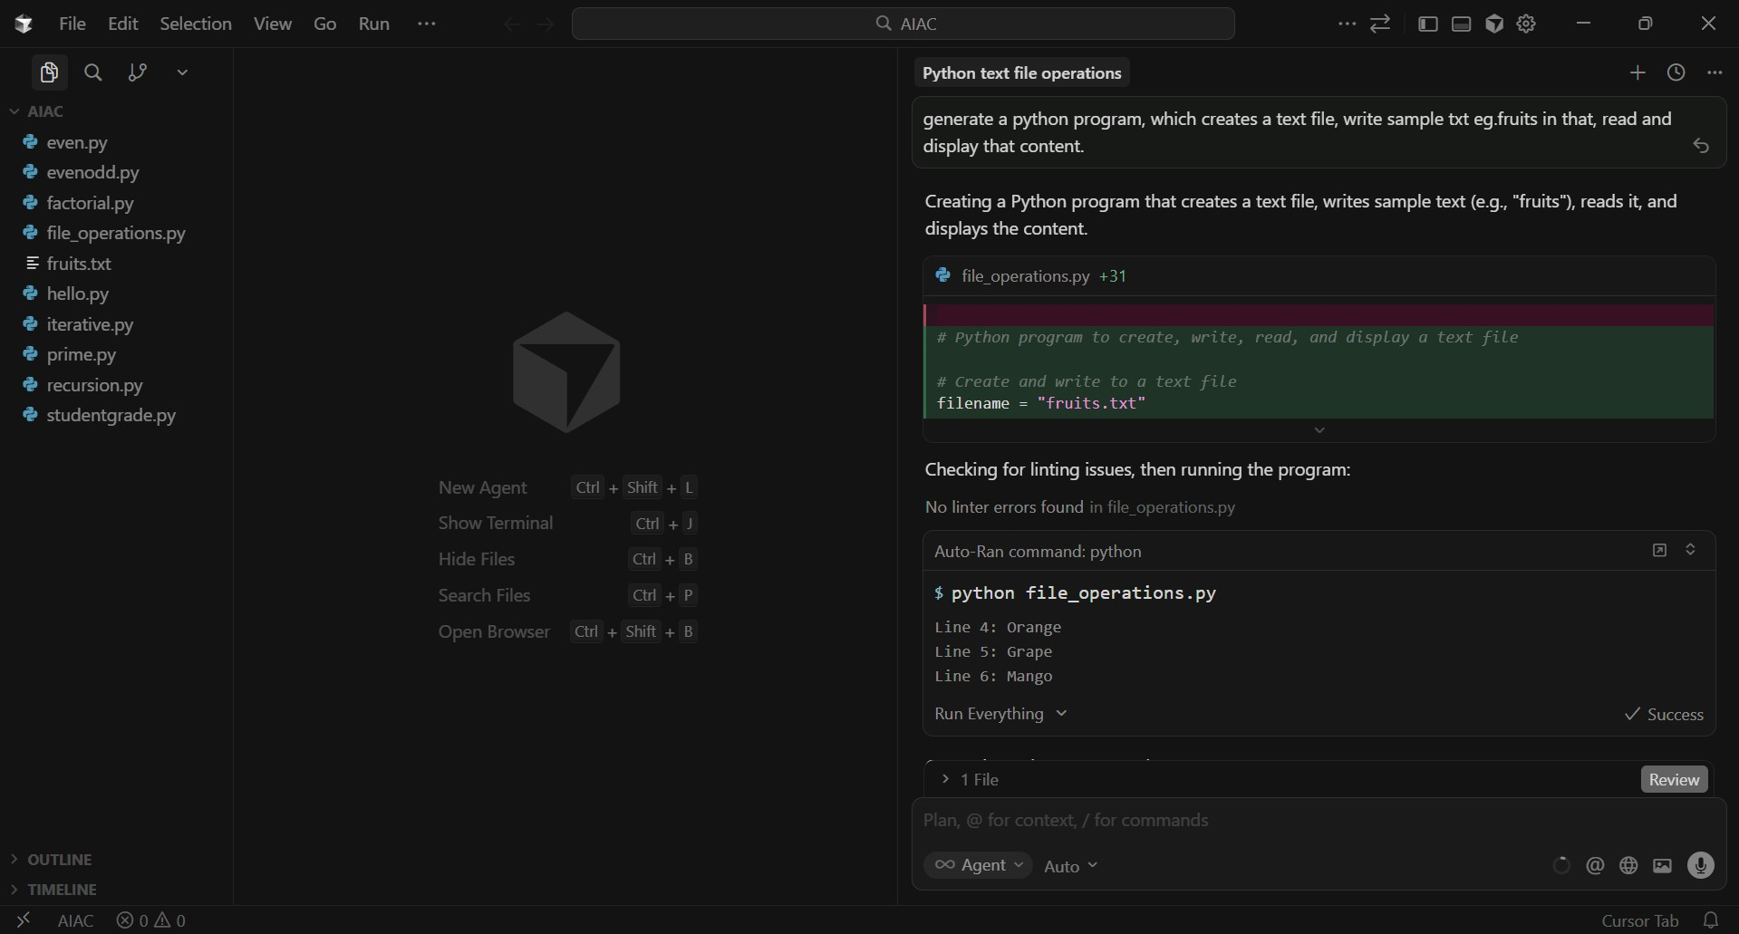

Code screenshot

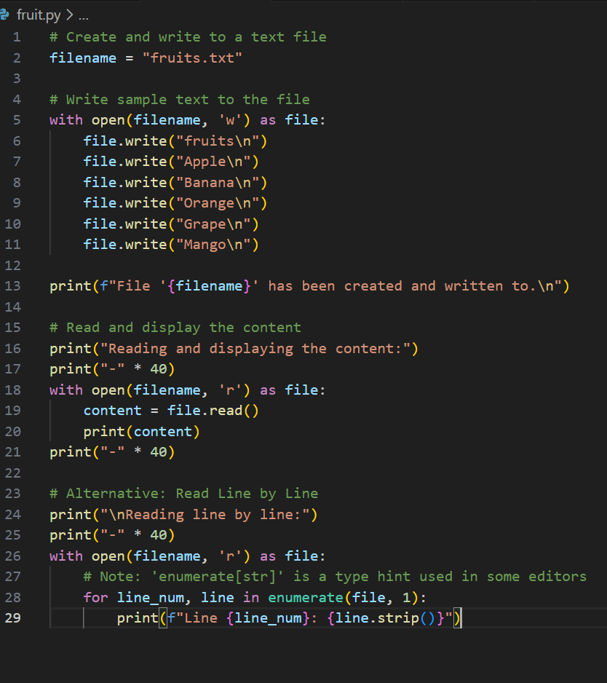

Output
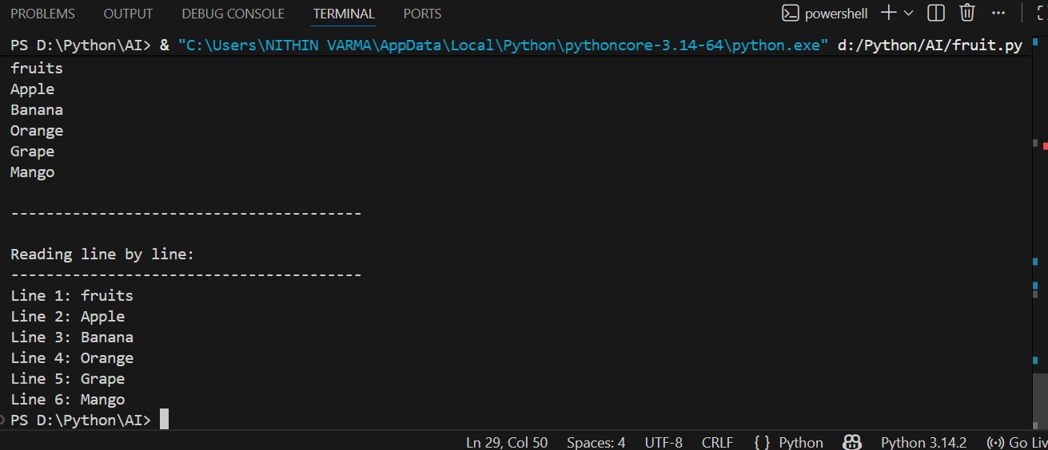
Explaination
This program demonstrates basic file handling in Python using Cursor.
First, a text file is created and sample text is written into it.
Then, the same file is opened in read mode and its contents are displayed on the screen.

Question
Task 3: CSV Data Analysis
Scenario: You are processing structured data from a CSV file. Task: Use Gemini in Colab to read a CSV file and calculate mean, min, and max.

Prompt
Generate Python code to read a CSV file and calculate the mean, minimum, and maximum values of a numeric column.

Code screenshot
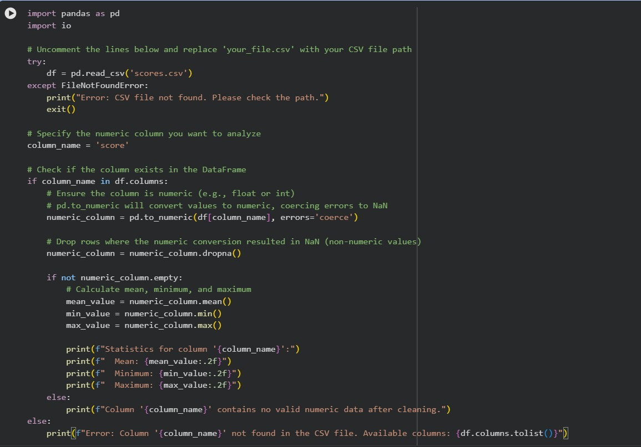
Output:
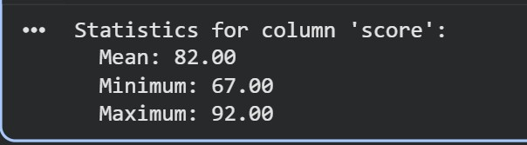
explaination
This program reads data from a CSV file using Python.
It extracts numerical values from a column and calculates the mean, min, and max.
CSV analysis is used in data processing and analytics applications.

Question
Task 4: Sorting Lists Manual vs Built-in
Scenario: You are reviewing algorithm choices for efficiency.
Task: Use Gemini to generate:
Bubble sort
Python’s built-in sort() Compare both implementations.

code screenshot
Manual Bubble Sort Code:
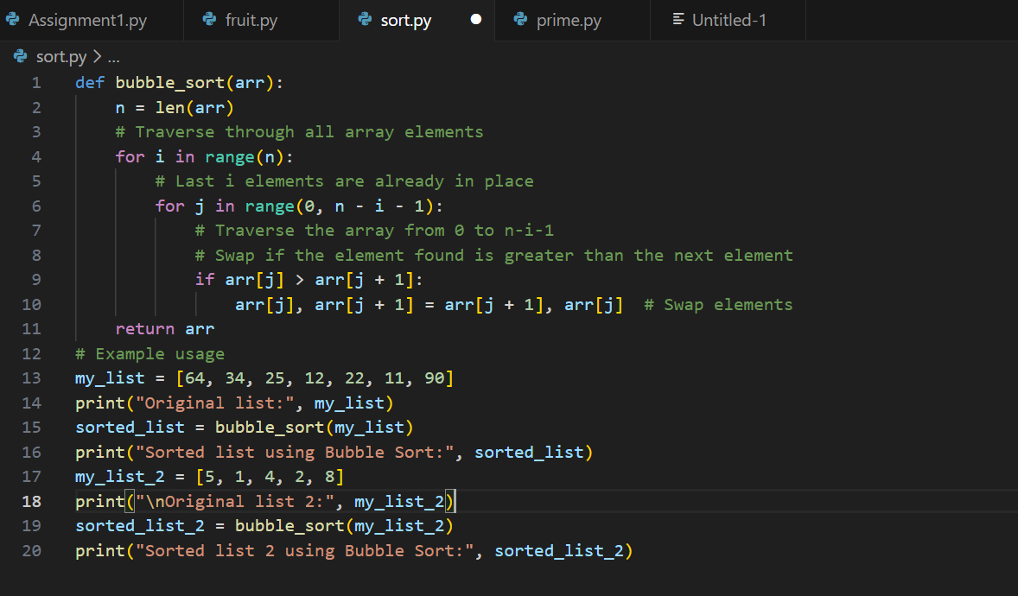
Sorting using sort() function:

output
Bubble sort:

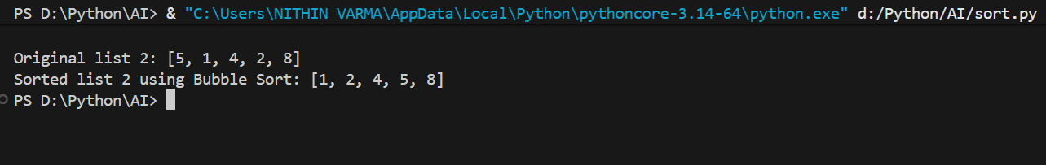

Sort Function:
explaination
Bubble sort is a simple sorting algorithm that repeatedly compares and swaps adjacent elements. It is easy to understand but inefficient for large data sets.
Python’s built-in sort function is shorter, optimized and much faster.

